Part 3: How our world will look with Peace of Mind, Inner Peace and Happiness all around us

Rebuilding our world with Peace of Mind, Inner Peace and Happiness all around us

Based on the information you have received so far, here’s the happiness pledge that an individual, couple, informal or formal small or large group needs to make to change our world:

“I / We pledge to do everything possible to enable world peace and stop being a part of the problem.”

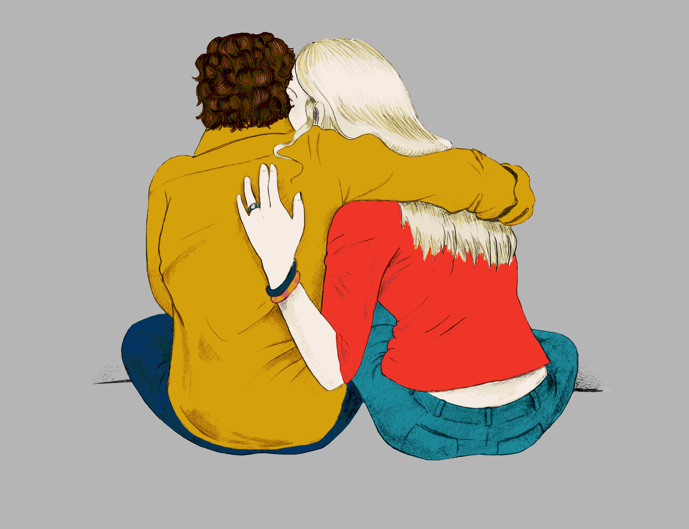

So now let’s examine the New World that will result from the Happiness Pledge. May I first point out that in each Individual in any conflict situation, every conscious reaction has a mental-emotional prompt or urge, which determines or triggers the behavior with which to respond. For rational behavior to occur, the psychological mechanism (the urge or emotion, which each person can control) that makes such a reaction possible must be working well. Therefore by people everywhere or a synergy of diverse individuals learning to maintain a self-controlled or self-regulated emotional state, none of us will want or encourage conflict and violence. This means that individuals, groups, and nations will stop fighting, killing people, and destroying property. We will all be mostly emotionally healthy. As a result, we will be able to accept one another and this will wipe out discrimination of all kinds. When we all enjoy IP/PoM (happiness) it means people everywhere will feel content with what they have; they be willing to share everything, and, in doing so, end scarcity and poverty for individuals and governments. There will be widespread good health and low mortality; and all societies will be productive without using unhealthy competition. All of these are outcomes of happiness. I hope you can see that happiness in everyone will create a powerful social re-alignment that could turn out to be a Cooperation Revolution similar to the Industrial Revolution. Please do not miss the fact that each of us must commit to achieving IP/PoM for world peace to happen. Start learning to do so with Mass Mental-Health Education for Everyone by yourself, with others or groups you set up.

And the time is now to use our ideas, energy, generosity and tenacity to bring IP/PoM to everyone, unconditionally. Folks, If not now, when? Our world is not getting better for everyone. With the capabilities and tools we have, we can achieve the goal of emotional wellbeing for EVERYONE in our lifetime. Mental peace is more desirable and much cheaper than economic prosperity, which almost everyone, especially political leaders everywhere, pursues. Nonetheless our mental-emotional state directs almost everything we think, say or do. If this is not healthy, everything that depends on it will be faulty. Let’s urge our politicians and bosses to come around to this way of thinking and so help make IP/PoM/happiness available to their constituents and workforce.

Undisciplined pursuit of economic prosperity is not only leaving behind a huge segment of people worldwide, because of disadvantage or handicap in the economic race but as a result it is also causing tremendous human suffering due to people’s inability to purchase or produce food, medicines, half-decent dwelling places and other life-sustaining needs such as personal safety. This situation cannot be blamed on the wealthy, corporate conglomerates etc. The desire to get and stay rich is a universal motivation. This striving is not different in a CEO of a large company from the same need in the lowest paid employee or an unemployed person anywhere in today’s world. Undoubtedly the same conditions will occur if these roles are reversed. If the individual earning the lowest wages becomes the CEO it will not take long before this previously poor individual, now CEO, will begin to want more. Money and power are addictive and sometimes insidiously corrupting.

Financial prosperity is not evil or wrong. When we put it ahead of everything all the time however, and try to get it all the time without hesitation or uneasiness regardless of whether the means to get wealth is unjust, fraudulent or conscienceless, this makes us less than human and equal to many members of the lower animal kingdom. It is time to meet the challenge of unequal access and prevent human misery in a way that will allow everyone to participate. We need to willingly change course from an adversarial or unfair system to a peaceful and universally accepting way of acquiring the good things in life. Otherwise like the Roman Empire our civilization will collapse from self-indulgence. For the sake of humankind, choose to live with IP/PoM and happiness.

Someone might say: “This all very idealistic. It is unrealistic to believe we can produce such a utopian world”. I remind everyone that very likely in the 1500s no one understood what the Industrial Revolution was, which today is considered a major pillar of human civilization. Before some people began to bring the plight of the environment to public consciousness early in the previous century the majority of us would not have seen an environmental movement as feasible or even necessary; and it would have been considered ludicrous to make a law to ensure its conservation. Today both activities are widespread. Even the issue of violence within the family was not seen as “a thing” or taken as serious at all, less than 50 short years ago. A then 25-year-old student, Lynn Zimmer, proposed the idea and with four other women co-founded Interval House, the first shelter for abused women and children in Canada, which opened in Toronto in 1973. Today there are close to 500 women's shelters and transition houses across the country. Unlimited accolades, ladies! You made history! The fact that in the US there are more animal shelters than there are shelters for victims of domestic violence means there’s much more left for others to do.

Nonetheless there are many such inventions we take for granted today (and I’d be remiss not to mention computers as one of these) that were inconceivable at some point before their introduction. Great inventions that have come to benefit mankind started with a dream someone had and so started the ball rolling. If YOU want this solution to go nowhere you will ignore it and hope others do the same, though a mystery why. Pick up this idea now as your own project and you will be in a coveted spot in history, the cutting edge of bringing about world peace.

Where do we go from here? Techniques and steps within everyone’s reach to provide or promote Inner Peace, Peace of Mind (IP/PoM) or Happiness

I encourage you to go forward with a strong desire to apply the happiness pledge and start working to acquire your own PI/PoM thereby making achieving world peace your project, knowing you must make the message believable and prosper.
Engage in Perception Training: Start giving every event that begins to upset you a positive or humorous spin in your head. Change the disturbing situation in your mind in anyway you can to see another side of it. Anger, worry and disgust etc are not solutions. They only steal your joy.
Use Self-talk and Thought Replacement whenever a thought, idea or report, about something you cannot change, is troubling. Use “this-will-make-me-untroubled” thoughts as replacement.
Meditation has proven to be effective for centuries and has been the most scientifically investigated technique for successfully bringing about IP/PoM – especially Mindfulness Meditation. Try both types.
Self-correct your weak areas to achieve and maintain the resilience of your happiness. It’s to your benefit.
Organize, support or fund the teaching, development and maintenance of IP/PoM/happiness skills through a variety of activities, such as: Gaming, Crossword Puzzles, Creative Apps, Children’s Speaking Toys and through attractive competitions – whatever is in your power or ability to do, particularly among those who are economically disadvantaged.
Sponsor and/or participate in Fundraising, Contests or Commissioning to design easy-to-teach-and-learn modules to acquire aspects of IP/PoM
Start a group, club or “political” party (one that is neither left or right but egalitarian), write a book, make a movie or music in any genre or start a new genre to raise consciousness about IP/PoM/happiness
If you are able only to pass the word around, as a believer in the power of IP/PoM/happiness to change people, who through combined effort will bring about a happier world, this will be an admirable contribution to make.
Be a mover and shaker: Start influencing others to make the Happiness Pledge.
Use and spread the news about Mass Mental-Health Education for Everyone.

Finally, as we all work individually and collectively to acquire IP/PoM, the COOPERATION REVOLUTION that results will remove the chances of social evils such as gun violence, organized crime, racism, misogyny, domestic violence, “allophobia” (fear that what’s different or unfamiliar causes harm), physical, financial and psychological harm, including child trafficking, slavery, addictions and war. We stop them by correcting perceptions, redirecting self-talk through thought-swopping before these social evils can become destructive domestic, community and global problems. You must recognize that the beginning point of these heinous and debilitating behaviors is always a mental-emotional need or expression gone wrong. With mental peace in all of us we can eliminate these problems. So use your communication, persuasion and influencing skills to spread the value of IP/PoM/happiness.

Use your business, political and intellectual power and skills and your wealth to make the teaching and learning of self-regulation or self-control universally and easily available. This project needs you! And you can rightfully own it; but we cannot do it on our own. Write to your governments, to politicians, school boards, social agencies; promote and propose the need for IP/PoM/happiness to groups to which you have access or in which you participate; feel free to use all or any part of this blog and any other material on this website to make your case. Don’t forget: Mass Mental-Health Education for Everyone. Keep practicing happiness yourself, with family members especially young children. It was young people who made the older folk care about environmental harm; together we will bring about world peace with inner peace. What do you have to lose?

