Part 2: Necessary Tools for World Peace
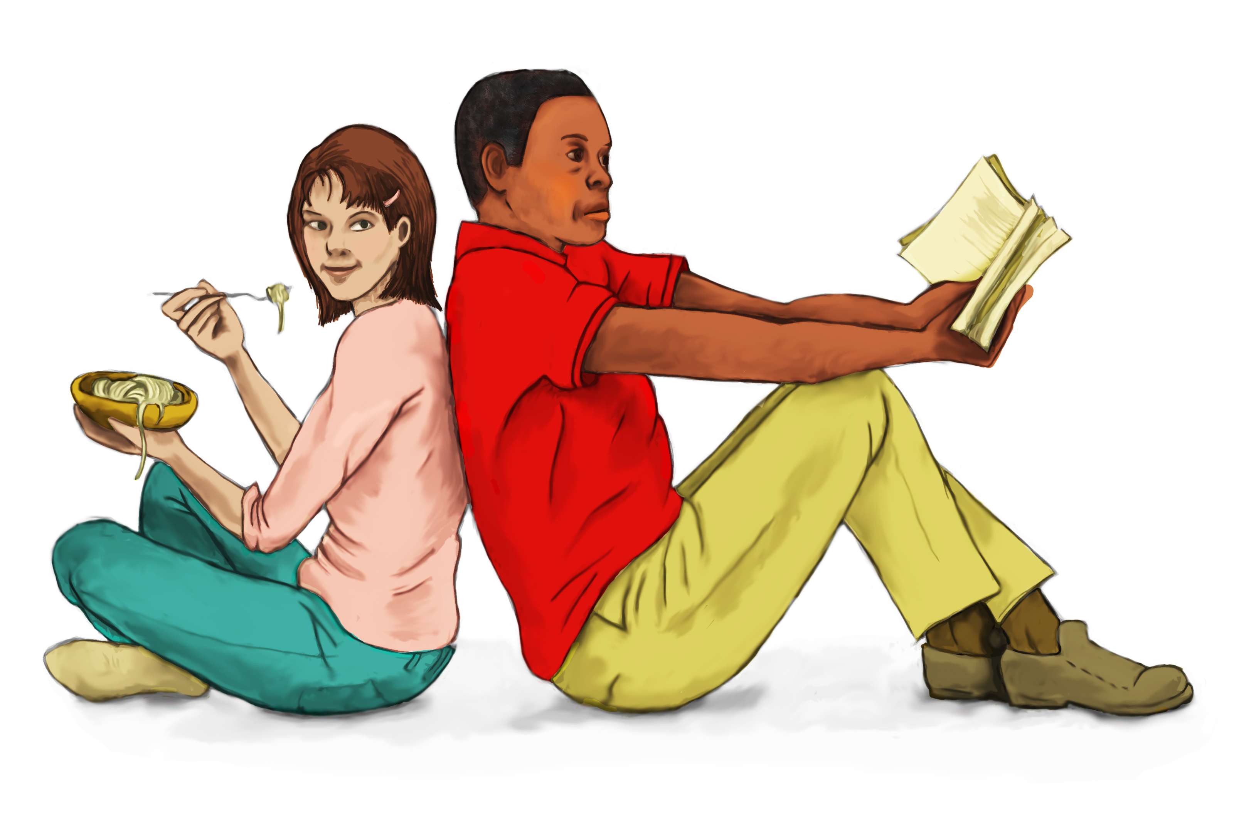
What about Group 2? This group comprises those who cannot see past potential obstructions to peace or don’t have ideas to contribute to addressing the problem of war for the following reasons:

The current state of the world is one in which unrest is creeping into almost every corner of the globe, disagreement within and between nations is increasingly pulling people apart rather than uniting them; and sooner or later lack of unity or disagreement leads to threatening and worsening tension or war. To most people these are huge problems. On a world scale the size of these real and potential problems seems too enormous and multi-dimensional to tackle. So the conclusion is: there’s no way to stop or avoid them. We can only try to contain them or deal with their results the best we can.
When we see huge institutions like the United Nations apparently unable to prevent or stop wars many feel even greater powerlessness. And so the argument from that perception becomes: If they can’t, who can?
Some would argue that we must accept these challenges because “human nature” is flawed. If it’s not one problem it will be another that we have to face as a species because we are not perfect. So, the reasoning is: Let’s advance the conditions of life to the extent possible, wherever we live or have influence.

A common thread that people in Group 2 perceive of how people relate to dealing with the problem of tensions and war in the world is that there are insurmountable barriers to eradicating war, which makes world peace unachievable. So there’s nothing to be done.

Viewed together, the people in Groups 1 & 2, share in the blame for making war persist because of the need and competition for material wealth that often leads to greed and/or a blocked view of attainable peace, producing inactivity due to apathy or a sense of helplessness. In other words the problems associated with greed and competition, to get and keep material wealth, promote war; and the problems that are due to apathy or indifference and helplessness prevent a solution. And then a certain way of thinking or mindset preserves either group of problems. My message is to point out that nonetheless, we are not forever doomed to be prevented from world peace by greed and apathy or competition and helplessness: The mindset can change. Truly, we are not subject to any overpowering force beyond our control that continues to dominate us. Even if till now it has seemed inevitable that we should be the servants of Fate, as Cassius told Brutus, in Shakespeare’s Julius Caesar (Act 1, Scene 2):

"The fault, dear Brutus, is not in our stars,

But in ourselves, that we are underlings."

Here’s a winning option in plain sight that we are free to choose but which till now has been “hidden”.

Remember the definition of Happiness/IP/PoM? It results when we adjust or transform our mental and emotional reactions to achieve maximum positive or pleasant emotions and minimum negative feelings… Each of us can produce these tools to make world peace happen. We know now that happiness produces better versions of ourselves. We also know that all kinds of emotional reactions can be switched on or off instantly by choice. Really? Yes, really. The mechanism by which to produce the reaction we want is called Self-Talk – Willful Self-Talk. At any point we are aware of an unhelpful thought or feeling, we can change it by telling ourselves to do so. This is why when someone slaps us we can stop ourselves from slapping right back if that someone is our aged grandmother or a hefty much bigger and stronger-looking individual. We don’t hit back because we tell ourselves (and sometimes not fast enough) this is not a time to hit back, thereby turning off the instinctive or habitual reaction. This is self-talk at work. So we just need to use this simple universally available process, Self-Talk, to switch off the destruction-causes of discord and war and turn on the survival and progressive peaceful intensions that IP/PoM/Happiness provides, to sustain ourselves and our planet. It’s that simple! The more we do this deliberately the more it changes our previous mindset. This is huge because we can change our mindset about anything that interferes with our IP.

We can engage self-talk at a thought replacement level. This just means swopping one thought for another: Deliberately take out the unwanted and supply the preferred thoughts. It is that straightforward. For example: When you think it is insulting to be called “cheap”, to avoid feeling hurt, angry or ashamed (in other words, to preserve your IP/PoM) you may replace such thinking by telling yourself: “I have a good reason to be cheap; he just doesn’t know that”, or “I won’t let myself become upset; she’s not aware of my financial situation”. Actually any different thought will do the trick, since the goal you are trying to achieve is to prevent yourself from getting upset. Therefore any thoughts that will set your mind on another path will do.

Another level of this self-regulation or self-management process aimed at preserving IP/PoM can be as extensive and involved as we need it to be; but in essence it is just a variation of thought replacement. For example practicing peaceful states through meditation starts with you saying to yourself “I need to look up meditation sites on Google or ask someone to help me at these times of upset, worry or anger” and at the earliest possible time you do just that. You are not going to be angry, sad or feel bad while you’re considering how to go about learning to meditate or while you are actually learning or doing meditation. In the same way focusing on and analyzing a scene, any scene, nearby or purposefully examining news information is really a slightly more complex form of switching thoughts than just changing a thought. These are all ways we may provide ourselves with maximum positive or pleasant emotions and minimum negative feelings… Going for psychological counseling starts with you agreeing you should, whether helped to do so or not; and then someone else, the counselor, getting you to agree with yourself that certain behaviors are important to perform. All through the sessions you are swopping previously held harming or irrational ideas with new healing or constructive ones. The words: “agreeing with yourself” is another way of stating the concept of changing mindset or perception. I agree with myself because my perception of the matter or my previous mindset changed. In other words I changed my way of thinking. Our perception of a situation determines how we will react to or in that situation. Each of us can practice swopping thoughts to remove negative and install positive emotional reactions, which over time will change our mindset or perception of any troubling situation. Therefore we can avoid fighting or attacking other individuals or countries using the same method. This means, in essence, we all need to learn what to do about healing our fear, anger, sadness, shame, guilt, discontent, ego and the many feelings that take away mental peace. Self-talk, thought replacement and changing our perception of stressful events will produce IP/PoM.

Another necessary tool with which to conquer mental-emotional disturbance, in other words keep happiness intact is Letting Go. Here too thought replacement can be an important strategy. Not letting go of an unacceptable event means you’re re-visiting the event in your mind and repeating the upsetting thoughts without any change in your emotionally injured perception of it. Let’s look at a general case. For example, addiction is the result of being unable to stop oneself from having more of a good thing.

Being unable to stop really means thinking one is unable to quit and also hanging on to thoughts that the experience is good. Sometimes there may be much more to the process as in the case of physiological addiction. This is when the body maintains the need for a substance because it has become dependent on it. Nonetheless, millions of smokers around the world stopped smoking because they stopped thinking it’s a good thing and replaced that way of thinking with a new mindset that says: Stop smoking; it’s not good for you; you can get cancer. And they used other thoughts along the lines of suffering and death. All thoughts can be swopped; we do it 50,000 to 70,000 times everyday, most of the time not even realizing. The desired result is guaranteed when you do succeed in changing mindset.

This is huge because we can change our mindset about anything, which interferes with our IP, including those contributing to war, unrest and the misery of others. To have a happy or happier life one needs to dispense with faulty perceptions in favor of thoughts that will create a constructive view of the problem and thoughts that persistently interrupt our harming and disadvantageous mental reactions till gradually weakening them and eventually pushing them aside for good. Thought Replacement and Letting Go are examples of Self-Regulation aka self-control.

Here’s one other way to switch for example, from being angry, sad, afraid, disgusted or ashamed. It is with… wait for it… laughter. Laughter really is the best medicine. Laughter, along with humor and cheerfulness is believed to result in a reduction of certain hormones that increase our negative reactions to stress. Such reactions create muscle tension and laughter causes the involved surrounding muscles to relax. At the point when you are laughing or even listening to laughter those other unpleasant emotions do not survive. Joy and misery cannot live together. Let joy move in, and distress will move out. You can also look for a humorous angle to what‘s upsetting or offensive or make something up that’s funny and try to see how much funnier you can make it. The more talented you are the more elaborate your mental skits will be; and if you’re stuck you can spend time examining the flaws in your attempts or even your self-observed lack of talent.

The final tool that everybody can use is: Disconnect from the source of your disruptive nemesis. Anyone has an option to leave or block their own access to the situation producing the triggering of unwanted responses. For example there are times when one may recognize that the best approach is to sever a relationship (temporarily or permanently) with the people or person that’s the problem or you may need to remove yourself in lieu of removing the offender. Admittedly any of these suggestions may sometimes prove to be tricky depending on the circumstances. Whenever possible however, limiting your exposure to any source of emotional pain is the best or most practical option. Even then healing of lingering effects of the previously stressful circumstance will require positive self-talk, thought replacement and/or letting go. Ensuring continued exposure to happiness-enhancing experiences is a very important task in the implementation of world peace. With the tools offered in this section (Part 2), happiness can defeat or defuse any tension or conflict! As a concrete step to acquiring IP/POM, a.k.a Happiness a teaching-learning program entitled: Mass Mental-Health Education for Everyone is available free of charge on the Publication page on this site. If you are serious about doing something to bring about peace everywhere then this program is your starting-point. It can and has to start with you. Otherwise you’ll be passing the buck, joining Group 1 or 2 and nothing will be done; and you’ll become a part of the problem.

